
HEMANT SIROHI
hemant.srh@gmail.com | +91 952-953-3359

Driven Product Marketing Manager adept at SEO and integrated marketing illustrated across 12+ years of experience in related roles. Strategic and innovative with a passion for driving brand awareness and product performance.

Professional Experience:

1 May 2020 – PRESENT
SEO Head
TABSCAP Inc.

Timely dispatch of periodical work reports to internal stakeholders in SEO projects. Optimize top performing content and provide recommendations that help enhance web content strategy.

1 SEP 2020 – 06 Nov 2020
SEO Specialist (Consultant)
Exoways Web Technologies Pvt. Ltd.

Strong growth/digital marketing skillset in a B2C or B2B2C environment (i.e. SEO, SMO, A/B testing, Google Analytics, Hotjar)

4 AUG 2015 – 17 DEC, 2019
Chief Marketing Officer (CMO)
Education Culture Pvt. Ltd.

SEO analysis, building and implementing media and marketing campaigns. Generating guidelines for building keyword specific content to meet client goals.

Education:

2012 - 2014
MBA IN INFORMATION TECHNOLOGY
SHITAS
Uttar Pradesh, India

2009 - 2011
BACHELOR OF ARTS
MGSU
Rajasthan, India

References:

Mr. Ashish Arora
Co-Founder
Infoshore Software Pvt. Ltd.
ashisharora83@gmail.com

Mr. Rohit Khariwal
Co-Founder & Director
Infoshore Software Pvt. Ltd.
rohit.khariwal@infoshore.biz

Mr. Dev Garg
Co-Founder & Director
Education Culture Pvt. Ltd.
devgarg@educationculture.net

1 MARCH 2013 – 26 APRIL 2015
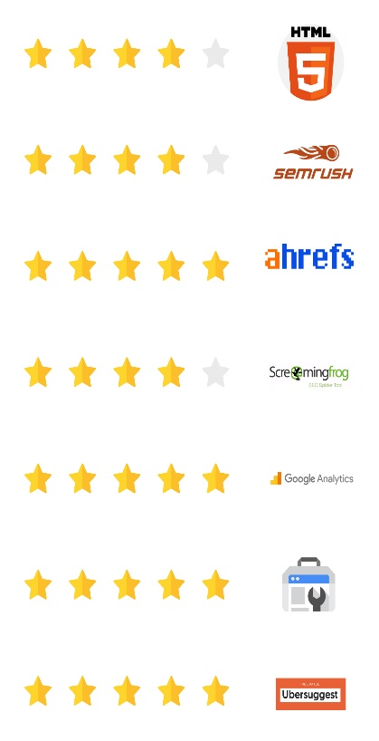
SEO Team Head
Ignis Way Infotech Pvt. Ltd.

Team management. Websites evaluation with respect to keywords, page optimization & project progress.

15 AUGUST 2010 – 27 FEBRUARY 2013
Senior SEO Associate
Infoshore Software Pvt. Ltd.

SEO copywriting/editing, social media optimization and marketing to improve overall visibility. Leveraging web 2.0 technologies for corporate marketing efforts for various company portals.

15 MAY 2008 – 1 MAY 2010
SEO Associate
Infoshore Software Pvt. Ltd.

Recruiting, training and managing a team of SEO professionals. Develop and implement SMM strategies for various clients.

Software Skills:

Projects:

FourModules
Assignment Help 4 Me
Easy Gym Software
Tabscap Inc.
SketchBubble
Presswala
An Indian Affair
And more than 35 projects.

